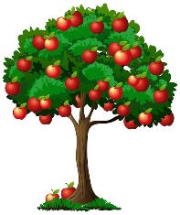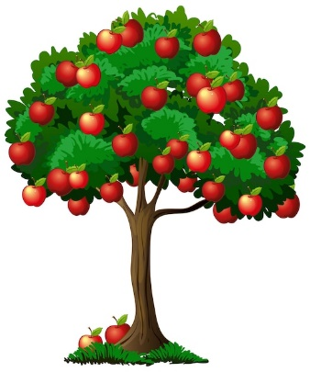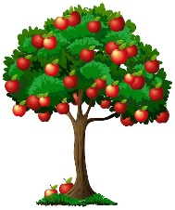

**HOW TO GROW A SMALL APPLE TREE**

Apple trees grow up to 30 feet tall. So-called dwarf varieties can still reach 20 feet in height making them difficult to care for and harvest.

Join our workshop on how to miniaturize trees so that they never grow taller than you! This makes caring for them and harvesting your apples, well, easy as pie!

**Saturday, May 18, 2024**

**10:30 a.m.**

1003 English Circle, Gooderham, ON

705 559-5972 or [info@tamaracklodge.ca](mailto:info@tamaracklodge.ca)

Advance registration is required

**BY DONATION**

Coffee and cake included

