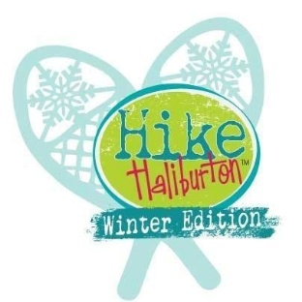
Health & Safety Guidelines - Hike Haliburton Participants
Winter Hike Haliburton events may involve hiking and snowshoeing in natural outdoor environments. These activities involve inherent risks. By participating, you accept these risks and take responsibility for your own safety.
Your Responsibility
You are responsible for:
- Ensuring you are physically able to participate
- Wearing proper winter footwear, snowshoes when required, and weather-appropriate clothing
- Dressing in layers and preparing for cold, wind, and changing conditions
- Bringing sufficient water, food, and any required medication
- Informing the Hike Leader of any medical concerns before the hike
- Following all instructions from the Hike Leader
If you are unable to continue at any time, notify the Hike Leader immediately.
Inherent Risks
Winter hiking and snowshoeing may involve snow and ice-covered terrain, slippery surfaces, roots, rocks, hills, changing weather, cold exposure, wildlife, fatigue, and possible injury.
Emergency Awareness
You understand that:
- Hikes may take place in remote winter conditions
- Emergency response may be delayed
- Only basic first aid may be available
- You may be required to walk out of a hike or be assisted from the trail if necessary
You consent to emergency assistance if you are unable to provide consent at the time.
Group & Environmental Safety
You agree to:
- Stay with the group unless directed otherwise
- Act respectfully and responsibly
- Stay on trails and leave nature undisturbed
- Carry out everything you bring in
Acknowledgement
By reading this document, you confirm that you understand the risks of winter hiking and your responsibility as a participant. You will acknowledge this understanding when signing the waiver.

